Quiz 1 – Jacob Dunn

- Write a program that makes a LED blink continually after the press of a button. Make sure that it blinks slow enough to observe. If you press the button again it should stop blinking.

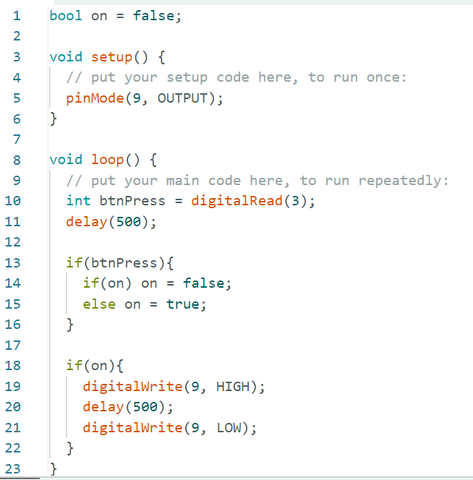

- Name 3 digital functions in Arduino.

digitalRead()
digitalWrite()
pinMode()

- What are the analog functions in Arduino and what are their respective ranges?

analogRead() – 10 bit (0-1023)
analogWrite() – 8 bit (0-255)

